**Exercise # 08**

**Question # 1**

In the field of number theory and cryptography prime numbers have a great significance, because they don’t have any factors. The prime number are usually found with the help of the primality test. There are many ways to perform the primality test. Three of these ways are

1. Through checking that a number is divisible from 2 to n-1 where n is the number.
2. Through checking that a number is divisible from 2 to n/ where n is the number.
3. Through checking that a number is divisible from 2 to $√(n)$ where n is the number.

Your task is to implement these all algorithms for primality test and generate 10 Million prime numbers. Next you need to report the time of each of the algorithm and also tell which one is best with respect to the time and which one is first by generating 10 Million numbers by each algorithm.

**Note: For square root you may apply the condition n*n < num;**

**Question # 2**

Write a C program that uses nested loops statements to display the calendar of a month. The user should be prompted to input the number of a month (1- for January, 2- for February ……) and the starting day of the month (1 - for Monday, 2-for Tuesday…). e. if the user 1 for month and 2 for day the program should print the calendar of the month like this.



**Question # 3**

Write a C program, which takes size and elements of the two arrays from the user and merges both of the arrays in ascending descending order and finally prints the resultant array.

**Question # 4**

Print the following pattern using nested loop in C.

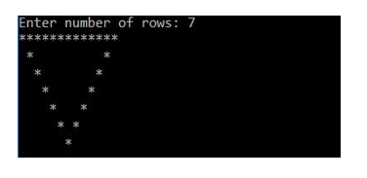

**Question # 5**

Write a C program Using array and loops to print out the sequence which does not have multiples of 3 and does not have 3 has the last digit. The program should print the nth term of the sequence whenever the user enters.

1, 2, 4, 5, 7, 8, 10, 11, 14, 16, …

Where 16 would be 10th term of the sequence.

**Note: Solve this using arrays and without arrays.**

**Question # 6**

In binomial theorem, one of the famous concepts is pascals triangle. Write a C program to print the pascal’s triangle. You must take number of rows as input from the user.

**Note: This for generating the binomial coefficients for pascal’s triangle.**

**C(line, i) = line! / ( (line-i)! * i! )**

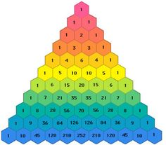

**Question # 7**

Write a C program to take array size and elements as input from user, then print the array, calculate mean, median and mode of the array and print the final results.

**Question # 8, 9 and 10**

Computer scientists have proposed many algorithms for reducing the searching complexity. One of the concepts is hashing algorithm which reduces the search complexity to O(1). The hashing techniques calculate the hash keys of input and stores the records accordingly.

James want to store the social security number of his 10 employees, for that person he wants to apply hashing and calculate the keys. h(k) = k mod 10 (where k is social security number). Here mod 10 is chosen because he wants to store only 10 records. The social security number his employees consist of 10 digits.

For this purpose, you have to Write a C program which takes 10 digits numbers from the users and calculates the hashes of the number and stores them in array accordingly against the hash which is being calculated. If the numbers entered are not according to the format program should print invalid format.

Furthermore, there are chances of collision in this problem, when two social security numbers may have same hash keys, so if this happens you must not store number which has already utilized hashing key.

Furthermore, the next thing is you must store the social security number according to the input sequence in another array.

Finally, you would have to search the social security numbers in both of the arrays. For the array in which you saved the social security numbers with respect to hash key you must search in the array in a similar way after calculating hash key of the record. For the array you have stored the social security numbers according to the sequence of entry you can iterate the whole array and perform the comparisons.

At last, you need to report the results and observations of normal searching and searching with the help of hashing.

**Note: You would cover hashing in data structures course in details, this is just a lab task and this does not portray complete concept of hashing as it would out of PF scope. You need to just write a program according to the instructions.**

**Best of luck**

**Quote for you guys**

**Talk is cheap**

**Show me the code**

**Linus Torvalds**